Using the SAMHSA OTP Extranet System:
Program Sponsor User Accounts

Completed by the American Institutes for Research under a grant to AATOD through the Substance Abuse and Mental Health Services Administration/DHHS
Contract # HHSP233201400268P

Using the SAMHSA OTP Extranet System: Program Sponsor User Accounts
October 2015
Completed by the American Institutes for Research under a grant to AATOD through the Substance Abuse and Mental Health Services Administration/DHHS
Contract # HHSP233201400268P
1000 Thomas Jefferson Street NW
Washington, DC 20007-3835
202.403.5000
www.air.org

Contents
1. Overview of the OTP Extranet System 1
1.1. OTP Extranet System Features 1
1.2. Types of User Accounts in the OTP Extranet System 1
2. Purpose of This User Guide 2
3. Establishing Program Sponsor User Accounts 2
3.1. Overview of the Program Sponsor User Account 3
3.2. Requesting Program Sponsor User Accounts 4
3.3. Selecting a Password 7
4. Program Sponsor Account Permissions and Responsibilities for SMA Forms 8
4.1. Permissions for Program Sponsors Responsible for Multiple OTPs 9
4.2. Certification Forms (SMA-162) 10
4.2.1. SMA-162 Overview 10
4.2.2. Program Sponsor User Accounts: Permissions for the SMA-162 Form 11
4.2.3. Creating a New SMA-162 12
4.2.4. Attaching Additional Required Documents to an Online SMA-162 13
4.2.5. What Happens After You Submit an Online SMA-162? 16
4.3. Patient Exception Request Forms (SMA-168) 17
4.3.1. SMA-168 Overview 17
4.3.2. When Should an Exception Request Be Submitted? 18
4.3.3. How Do Program Sponsors Support the OTP’s Submission of Patient Exception Requests? 18
4.3.4. Creating an Exception Request 19
4.3.5. Saving an Exception Request 22
4.3.6. What Happens When a Patient Exception Request Is Saved? 23
5. Preferences and Account Management 24
5.1. Managing the OTP’s Extranet Accounts 24
5.2. Viewing and Monitoring Submitted SMA-162s 25
5.3. Managing Submitted SMA-168s: Archiving and Printing 25
5.4. Managing Your Account 26
5.4.1. How Do I Change My Password? 26
5.4.2. I Forgot My Password—What Do I Do? 27

Exhibits
Exhibit 1. Required Steps for Creating a Program Sponsor User Account 4
Exhibit 2. Screenshot of the OTP Extranet User Account Request Form Homepage, Emphasizing the Program Sponsor Account Type Menu Option 4
Exhibit 3. First Screenshot of the Program Sponsor Account Request Form (Partial Contents) 5
Exhibit 4. Second Screenshot of the Program Sponsor Account Request Form (Partial Contents), Highlighting a Link for Requesting Account Permissions for Multiple OTPs 5
Exhibit 5. OTP Extranet Program Sponsor Account Terms of Use, Extracted from the Online Program Sponsor Account Request Form 6
Exhibit 6. Screenshot of Automatically Generated Web Page Confirming Receipt of Program Sponsor Account Request 7
Exhibit 7. Screenshot Displaying a Program Selection Screen for Program Sponsors With Access to Multiple OTPs 9
Exhibit 8. Screenshot Emphasizing the Program Sponsor’s Name and Selected Program for Program Sponsors with OTP Extranet System Access to Multiple OTPs 10
Exhibit 9. Screenshot Showing the SMA-162 Menu Tab, Highlighting Features for Creating a New SMA-162 and Selecting the Application’s Purpose 12
Exhibit 10. Screenshot Showing the Main SMA-162 Menu Screen, With Arrow Highlighting a Link for Obtaining Detailed Instructions for Completing the SMA-162 13
Exhibit 11. Example of the OTP Extranet’s Features for Uploading Required Attachments to an SMA-162 Application (Renewal/Re-Certification) 14
Exhibit 12. Second Example of the OTP Extranet’s Features for Uploading Required Attachments to an SMA-162 Application (Change in Medical Director) 14
Exhibit 13. Listing of Required Attachments for Each Type of SMA-162 Submitted Through the OTP Extranet System 15
Exhibit 14. Screenshot Illustrating the List of Submitted SMA-162s and Features for Viewing Their Purpose and Status 17
Exhibit 15. Screenshot of the OTP Extranet Homepage for Program Sponsor Accounts, Highlighting the Option to “Create an Exception Request” 19
Exhibit 16. Screenshot of a Partial SMA-168, Newly Created with Pre-Populated Program Sponsor Name and Title 20
Exhibit 17. Instructions for Completing the Items in SAMHSA form SMA-168 21
Exhibit 18. Screenshot of Options Available to Program Sponsor Account Holders After Completing an SMA-168 22
Exhibit 19. Screenshot of a Confirmation Message Displayed by the OTP Extranet System When an SMA-168 Form Is Saved 23
Exhibit 20. Screenshot Displaying the OTP’s Saved (But Not Submitted) Patient Exception Requests 23
Exhibit 21. Screenshot of the “Manage Accounts” Menu for Viewing and Disabling Active OTP Extranet User Accounts, and Approving or Denying Account Requests 24
Exhibit 22. Screenshot of Submitted Exception Requests List Highlighting Print and Archive Options 25
Exhibit 23. Screenshot of Archived Patient Exception Requests List Highlighting the Print Option 26
Exhibit 24. Screenshot of the “My Account” Tab Displaying the “Change My Password” Feature 27
Exhibit 25. Screenshot Displaying the OTP Extranet Log-In Site, With “Forgot Password?” Feature 28
Exhibit 26. Screenshot of Log-In Support Page, With Password Change Confirmation Pop-Up Window 28

Overview of the OTP Extranet System
The OTP Extranet automated data processing website (the OTP Extranet system) helps the Division of Pharmacologic Therapies (DPT)—part of the Substance and Mental Health Services Administration’s (SAMHSA’s) Center for Substance Abuse Treatment (CSAT)—achieve its goal of processing the certification of SAMHSA’s opioid treatment programs (OTPs) through automated submissions and approval queues among facility, state, and federal staff. The site also supports the automated processing of provider requests for treating specific patients in a manner divergent from guidelines for opioid therapies (patient exception requests). The OTP Extranet system greatly increases the accuracy and ease with which CSAT is able to monitor and facilitate OTP compliance with federal regulations.

OTP Extranet System Features
Several features of the OTP Extranet system help CSAT fulfill its OTP compliance requirements in a timely manner. These features include
- Automated letter generation,
- Online submission of SAMHSA forms (“SMA forms”) approved by the Office of Management and Budget (OMB) to collect information necessary for program certifications and determinations of permissible exceptions to treating individual patients in accordance with federal opioid treatment standards, and
- Identification of impending accreditation and certification expirations.

Types of User Accounts in the OTP Extranet System
Currently there are four types of user accounts in the OTP Extranet system that are available to OTP personnel. Each is role specific, with a unique combination of user permissions:
- Counselor user account—intended for non-physician OTP staff whose job duties support the OTP’s submission of patient exception requests;
- Program Physician user account—intended for Medical Directors and other clinicians authorized to sign and submit the OTP’s patient exception requests;
- Program Director user account—intended solely for the OTP’s Program Director; and
- Program Sponsor user account—intended solely for the OTP’s Program Sponsor.
Users should note that the names of these four OTP Extranet system accounts do not always reflect the job title or position name held by the account holder at the OTP. For example, “Counselor” account holders do not have to have a job title of “counselor” at the OTP; rather, all non-physician staff who support the OTP’s submission of patient exception requests (e.g., filling out the forms for physicians to sign) may hold a “Counselor” account if approved to do so by SAMHSA and the OTP administrator. Approval of account requests is discussed in Section 3.2.
In some cases, an individual staff member meets the criteria for a Program Director or Program Sponsor account type and a Program Physician account type. For these special cases, the accounts may be combined, thus combining the permissions of the two account types.

Purpose of This User Guide
The purpose of this user guide is to provide an overview of the Program Sponsor account type including its features and functions and to provide an accessible and user-friendly resource for users as they interact with the OTP Extranet system. Separate user guides have been developed for the Counselor, Program Physician, and Program Director account types. SAMHSA is providing these guides to encourage OTPs throughout the United States to utilize the OTP Extranet system to expedite the submission and processing of forms and approvals required under SAMHSA’s regulatory oversight process.
Note: If this guide does not sufficiently address specific questions you have about Program Sponsor user accounts, please contact the SAMHSA OTP Extranet Information Center for assistance at 1-866-OTP-CSAT (8:30 a.m.–5 p.m. Eastern M–F) or by e-mail at otp-extranet@opioid.samhsa.gov.

Establishing Program Sponsor User Accounts
This section provides an overview of the Program Sponsor user account, describing for whom this account type is intended and providing brief information on permissions and restrictions. The process for requesting a Program Sponsor user account is also described, as well as the process for approving account requests and password requirements. Program Sponsor accounts can only be created if the person requesting the account is already listed in the OTP Extranet system as the Program Sponsor for the respective OTP. For new Program Sponsors in existing programs, the OTP should file an SMA-162 form that names the new Sponsor prior to the new Sponsor applying for the OTP Extranet account. For new programs without a Program Sponsor, the OTP should follow the guidance provided in the footnote to Section 4.2.1 in this user guide for submitting an SMA-162 via the SAMHSA Medication-Assisted Treatment (MAT) website.

Overview of the Program Sponsor User Account
Program Sponsor user accounts are available to individuals currently employed at a SAMHSA-certified OTP as the program’s official Program Sponsor. The Program Sponsor account type provides full permissions for signing OMB form SMA-162, the Application for Certification to Use Opioid Drugs in a Treatment Program Under 42 CFR, Part 8.11, and permits the Program Sponsor to support the OTP’s online submission of OMB form SMA-168, the Exception Request and Record of Justification under 42 CFR 8.12. An SMA-168 must be submitted and approved whenever a physician wishes to vary from the opioid treatment standards set forth in federal regulation 42 CFR 8.12 in the treatment of an individual patient. The SMA-162 is used by SAMHSA/CSAT’s Division of Pharmacologic Therapies to determine if an OTP is qualified to provide opioid treatment under 42 CFR Part 8 and to process renewals, re-certifications, and program changes. All OTP Extranet system users supporting the OTP’s submission of SMA forms require an individual user account; accounts should not be shared among staff.
Program Sponsor account holders may have one user account, applicable for all OTPs in which they work, but there can be only one Program Sponsor account assigned per OTP. A person’s e-mail address is used as the user name. The e-mail address must be unique to the person applying for the account. For Program Sponsors who are also physicians qualified and approved to sign and submit the program’s SMA-168 forms, the Program Sponsor account type may be combined with the Program Physician account type, thus combining their permissions. For security purposes, any OTP Extranet user account that is not used for one year is deactivated.
Users with Program Sponsor accounts can
- Approve or deny pending OTP Extranet account requests for personnel at their OTP(s);
- Disable any OTP Extranet account associated with their OTP(s);
- Create, submit, and sign SMA-162 forms online and receive automated correspondence during SAMHSA’s review process;
- View all SMA-162 forms for the OTP(s) with which their accounts are associated;
- Create, save, and modify SMA-168 forms; and
- View and print all signed/submitted and archived SMA-168 forms from their OTP(s).
Users with Program Sponsor accounts cannot
- Sign or submit an SMA-168 form. A user must have a Program Physician account in order to sign and submit an SMA-168. Unless the Program Sponsor has a combined account type (i.e., Program Sponsor and Program Physician account permissions), the Program Sponsor cannot sign or submit the program’s SMA-168 forms.

Requesting Program Sponsor User Accounts
As shown in Exhibit 1, there are seven steps in creating a Program Sponsor user account.
Exhibit 1. Required Steps for Creating a Program Sponsor User Account
STEPS | ACTIVITIES
Step 1 | Request an account. Visit http://otp-extranet.samhsa.gov/request
Step 2 | Select the “Program Sponsor” tab. This will launch the Program Sponsor Account Request Form.
Step 3 | Complete the Program Sponsor Account Request Form. All fields are mandatory, except for “OTP address line 2.”
Step 4 | Accept the Terms of Use. Review the account Terms of Use and indicate acceptance and understanding.
Step 5 | Review the Submission Confirmation Page. Receive and view a confirmation web page indicating SAMHSA’s receipt of the Program Sponsor Account Request Form.
Step 6 | Check e-mail. Receive and review an e-mail from otp-extranet@opioid.samhsa.gov, the SAMHSA OTP Extranet Information Center’s mailbox.
Step 7 | Respond to the e-mail within 7 days. No text is necessary in the response; click reply and then click send. This will complete your request for an account.
These steps are further described below; screenshots from the OTP Extranet system are provided where appropriate. The first step in creating a Program Sponsor account is to submit a request for an account at http://otp-extranet.samhsa.gov/request. When the OTP Extranet User Account Request Form homepage appears, select the “Program Sponsor” option (illustrated in Exhibit 2 below). This will bring up the Program Sponsor Account Request Form (shown in Exhibits 3 and 4).
Exhibit 2. Screenshot of the OTP Extranet User Account Request Form Homepage, Emphasizing the Program Sponsor Account Type Menu Option
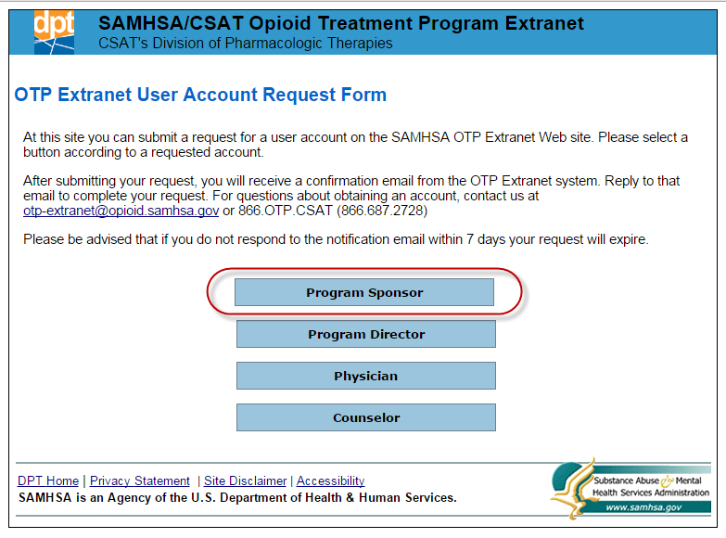
Exhibit 3. First Screenshot of the Program Sponsor Account Request Form (Partial Contents)
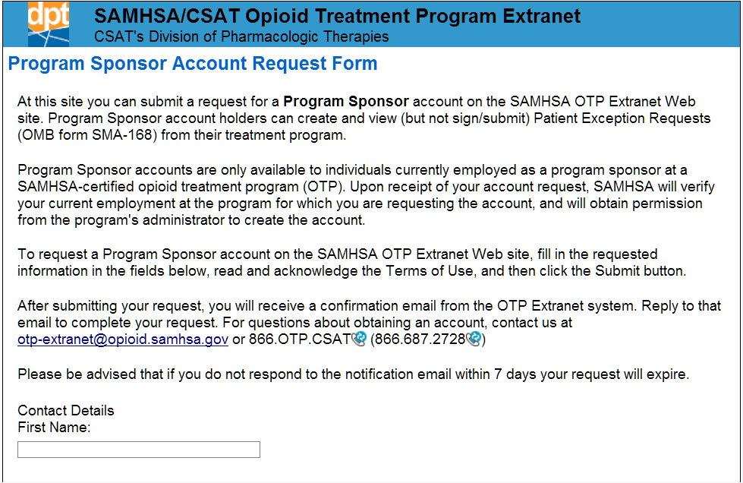
Exhibit 4. Second Screenshot of the Program Sponsor Account Request Form (Partial Contents), Highlighting a Link for Requesting Account Permissions for Multiple OTPs
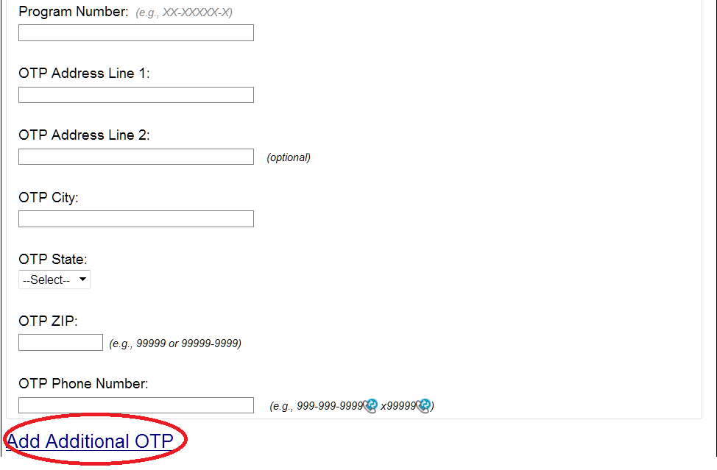
As shown in Exhibit 4, the Program Sponsor Account Request Form includes basic contact information about the applicant (e.g., first and last name, e-mail address) and about the OTP for which the Program Sponsor account is being created (e.g., OTP program name, program ID number, OTP address and phone number). All fields on this form are mandatory, except for “OTP Address Line 2.” The Program Sponsor account applicant must be the only person with access to the e-mail account entered on the form. The “Program ID Number” entered on the form should be the program’s official OTP number, sometimes known as a SAMHSA number. As shown in Exhibit 4, access to multiple OTPs can be requested by clicking on the link to “Add Additional OTP.”
After completing the information fields, review the account’s Terms of Use provided at the bottom of the form (Exhibit 5). Indicating acceptance and understanding of the Terms of Use will complete your online form submission. You will then view a confirmation web page (Exhibit 6). This page lets the applicant know that the account request was received and that a confirmation e-mail will be sent to the applicant after the form is submitted.
Exhibit 5. OTP Extranet Program Sponsor Account Terms of Use, Extracted from the Online Program Sponsor Account Request Form
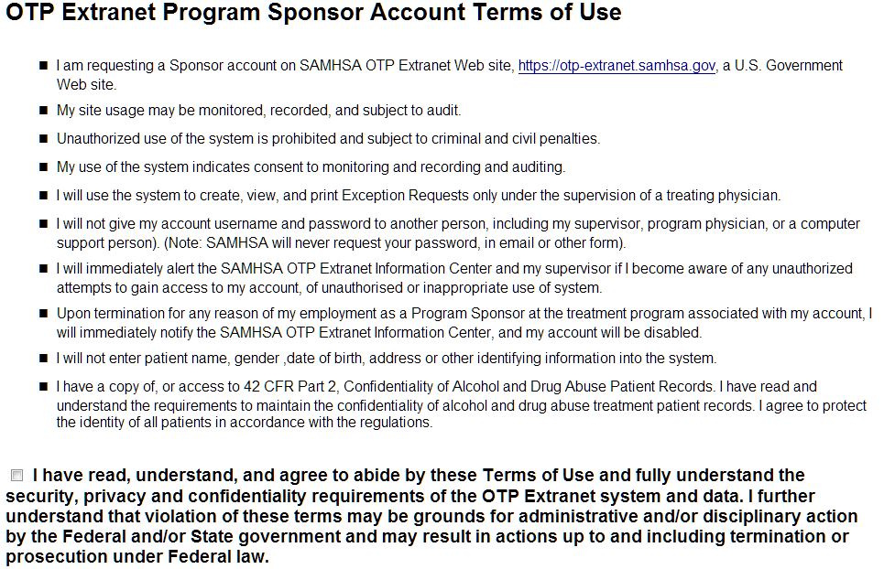
Exhibit 6. Screenshot of Automatically Generated Web Page Confirming Receipt of Program Sponsor Account Request
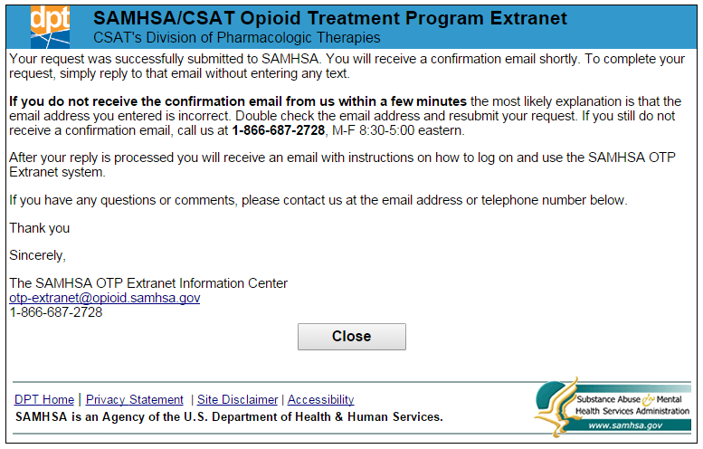
As indicated in the screenshot of the confirmation web page shown in Exhibit 6, each applicant who completes a Program Sponsor Account Request Form will receive a confirmation e-mail. Reply to the confirmation e-mail within 7 days using the same e-mail address to which the confirmation e-mail was sent. No text is needed in the body of the e-mail reply; simply hit “reply” and send the e-mail. SAMHSA OTP Extranet Information Center staff can process the account request only after receiving a reply to the confirmation e-mail. If a reply is not received within 7 days, Information Center staff considers the request to be unverified and a new Program Sponsor Account Request Form will need to be completed and submitted.
Upon receipt of the e-mail reply, SAMHSA will verify your current employment at the program for which you are requesting the account. An e-mail notification containing a temporary password for accessing the Program Sponsor account will be sent to you.

Selecting a Password
You will be prompted to change the password the first time you log in to the OTP Extranet system with your new account. Your password must meet the following five Department of Health and Human Services’ (HHS) security requirements:
- Must be between 8 and 30 characters.
- Must contain at least one uppercase (capital) letter (e.g., A, B, etc.) and one lowercase letter (e.g., a, b, c, etc.).
- Must contain at least one digit (e.g., 1, 2, 3, etc.).
- Must contain at least one special character. Special characters can be a punctuation mark or any other symbol on your keyboard (e.g., @ ! $ % * ? +).
- Cannot include any actual words (referred to as “dictionary words”). For example, you may not use the word “book” in your password, but you may use“b00k” instead (using zeroes instead of the letter “o”). Certain common names may also be considered words, so please keep this in mind when selecting a password.
Once your account is established, you will be required to change your password every 90 days. Instructions for changing your password and for resetting a forgotten password are provided in section 5.4 of this user guide.

Program Sponsor Account Permissions and Responsibilities for SMA Forms
This section provides information about SAMHSA required forms SMA-162 and SMA-168 and describes Program Sponsor account permissions related to an OTP’s online submissions of each type of form. For Program Sponsors who work in more than one OTP, account permissions for accessing SMA forms from multiple OTPs are also discussed. Program Sponsor account permissions discussed in this section include the following:
- Creating a new SMA-162;
- Signing and submitting SMA-162s to SAMHSA and the State Opioid Treatment Authority (SOTA);
- Creating a new SMA-168;
- Saving an SMA-168 for later completion, or for later submission by a Program Physician account holder;
- Modifying an SMA-168 that has not yet been submitted by a Program Physician account holder; and
- Viewing, printing, and archiving patient exception requests for the OTP(s) associated with the Program Sponsor’s account(s).

Permissions for Program Sponsors Responsible for Multiple OTPs
As discussed in Section 3.2, Program Sponsors who work at multiple OTPs may request OTP Extranet system access rights for each of their OTPs. Program Sponsor account holders approved to access multiple OTPs may select the OTP they want to initially access during their OTP Extranet session by selecting from among their listed programs during the log-in process as shown in Exhibit 7.
Exhibit 7. Screenshot Displaying a Program Selection Screen for Program Sponsors With Access to Multiple OTPs
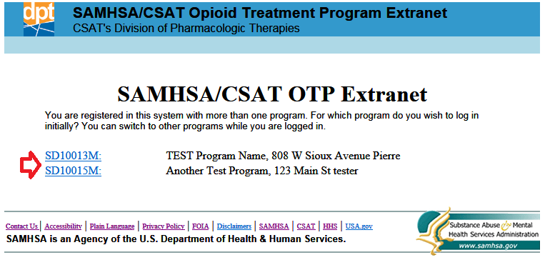
The OTP number for the selected program appears in a drop-down menu located under the Program Sponsor’s name, as shown in Exhibit 8. During an OTP Extranet session, Program Sponsors may switch to any of their authorized programs by selecting a different program on the drop-down list.
Exhibit 8. Screenshot Emphasizing the Program Sponsor’s Name and Selected Program for Program Sponsors with OTP Extranet System Access to Multiple OTPs
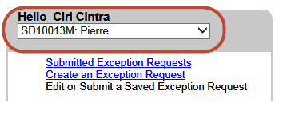

Certification Forms (SMA-162)

SMA-162 Overview
Certification is the process by which the SAMHSA/CSAT’s Division of Pharmacologic Therapies determines that an OTP is qualified to provide opioid treatment under 42 CFR Part 8. To obtain SAMHSA certification, OTPs must successfully complete an accreditation process and meet other requirements enumerated in 42 CFR Part 8. A program may apply to SAMHSA for provisional (initial) certification during the time it is working toward accreditation with a SAMHSA-approved accrediting body. Provisional certification is a temporary certification granted for up to one year to a new OTP. The program must become accredited during the one-year provisional time frame.
Upon achieving accreditation, a provisionally certified OTP must apply to SAMHSA for renewal to achieve “full” certification. Once certified, programs must renew certification (also known as “re-certifying”) at least every 3 years.
Form SMA-162 is required by 42 CFR Part 8.11 for application and processing of
- Provisional certifications,
- Renewals of provisional programs into full certification status, and
- Re-certifications of fully certified programs.
The form is also used to apply for SAMHSA approval of four types of changes at existing programs:
- A new Program Sponsor,
- A new Medical Director,
- Relocation of the primary dispensing unit or a medication unit, and
- The addition of one or more new medication units (e.g., satellite clinic or mobile unit).
The OTP Extranet system accommodates the online processing of SMA-162s for Renewals/
Re-certifications and the four program changes listed above. However, the online processing of provisional certifications must be submitted through SAMHSA’s Medication-Assisted Treatment (MAT) website at http://www.samhsa.gov/medication-assisted-treatment/opioid-treatment-programs/apply.
It is beyond the scope of this user guide to describe the accreditation and certification requirements for OTPs, including the state-specific variations in applicable statues and regulations affecting compliance. Program Sponsors requiring additional information on these topics prior to completing the SMA-162 are referred to the SAMHSA MAT website, which provides detailed information about the accreditation and certification process (http://www.samhsa.gov/medication-assisted-treatment/opioid-treatment-programs/apply). For state-specific questions, SAMHSA maintains a current list of State Opioid Treatment Authorities (SOTAs) at: http://dpt2.samhsa.gov/regulations/smalist.aspx.

Program Sponsor User Accounts: Permissions for the SMA-162 Form
Program Sponsor account permissions related to an OTP’s online submission of certification forms include the following:
- Creating, submitting, and signing a new SMA-162 for the purposes described in Section 4.2.1.
- Interacting with SAMHSA to complete full processing of the form, including
  - Reviewing and responding to a confirmation e-mail from SAMHSA,
  - Modifying the form,
  - Uploading new documents requested by SAMHSA, and
  - Providing clarifications to SAMHSA.
Program Sponsors do not have to complete the SMA-162 themselves; OTP personnel holding a Program Director user account type may also complete or modify an SMA-162 form and submit the form for the Program Sponsor’s signature. Only a Program Sponsor account holder may sign the SMA-162. The process for creating a new SMA-162 is described in Section 4.2.3. The process for signing the SMA-162 is described in Section 4.2.5.

Creating a New SMA-162
To create a new SMA-162 through the OTP Extranet system, click on the SMA-162 tab in the top menu of the Program Sponsor home screen and select “New SMA-162” from the links appearing under the Program Sponsor’s name, as shown in Exhibit 9. Select the purpose of the SMA-162 application from among the listed active choices shown in “Purpose of Application” (also shown in Exhibit 9). Because provisional certifications are submitted into the OTP Extranet system through the SAMHSA MAT website (as described in Section 4.2.1), the “Provisional Certification” option is not active on the OTP Extranet’s online SMA-162 form.
Exhibit 9. Screenshot Showing the SMA-162 Menu Tab, Highlighting Features for Creating a New SMA-162 and Selecting the Application’s Purpose
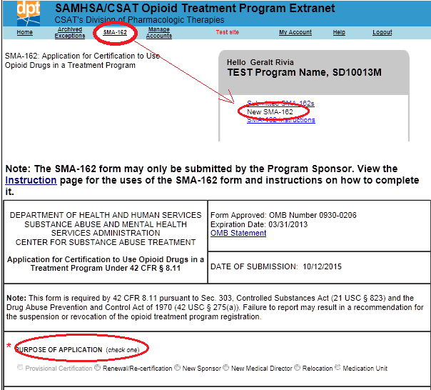
Detailed instructions for completing the SMA-162 are available within the OTP Extranet system by selecting the “SMA-162 Instructions” link under the Program Sponsor’s name within the SMA-162 menu page, as shown in Exhibit 10. The instructions may be printed from within the OTP Extranet system. The Program Sponsor's name and contact information, including telephone number and e-mail address, are required on the form.
Exhibit 10. Screenshot Showing the Main SMA-162 Menu Screen, With Arrow Highlighting a Link for Obtaining Detailed Instructions for Completing the SMA-162
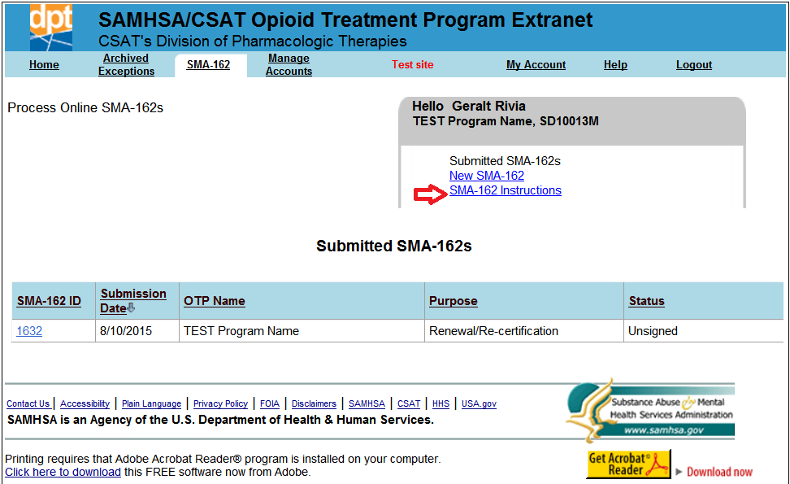

Attaching Additional Required Documents to an Online SMA-162
Depending on the purpose(s) of the SMA-162 form, additional documentation (e.g., description of program accreditation status) will need to be provided to SAMHSA. Required documents can be attached in electronic format on the second page of the online SMA-162. Specifications about which documents are needed for each type of SMA-162 request are available from within the OTP Extranet system and can be found by selecting the “SMA-162 Instructions” link described in Section 4.2.3 and shown in Exhibit 10.
The OTP Extranet system will generate a checklist of required attachments based on the type of application selected as the “Purpose of Application.” To exemplify this feature, the checklist of required documents for a Renewal/Re-certification is shown in Exhibit 11; the checklist of required documents generated for a change in Medical Director is shown in Exhibit 12.
Exhibit 11. Example of the OTP Extranet’s Features for Uploading Required Attachments to an SMA-162 Application (Renewal/Re-Certification)
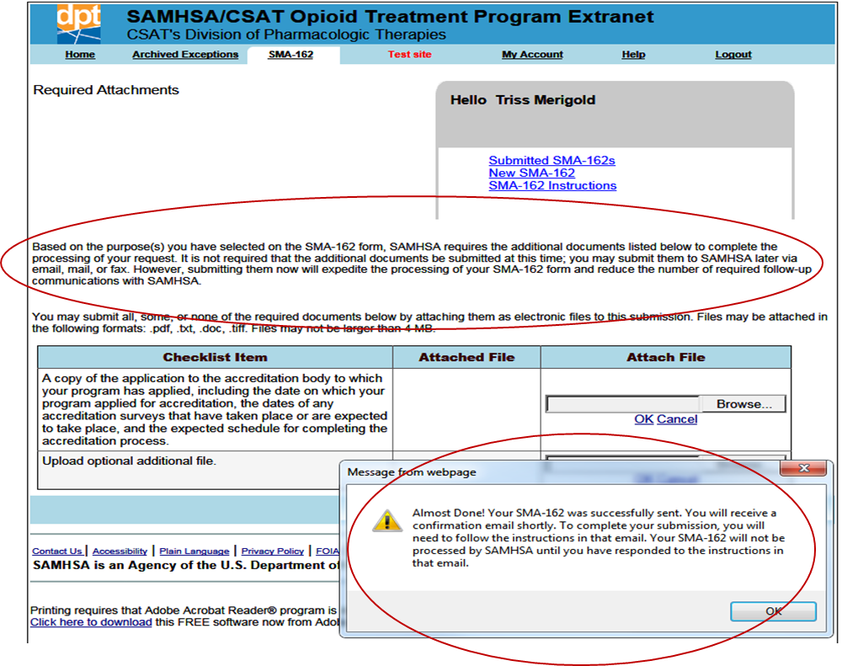
Exhibit 12. Second Example of the OTP Extranet’s Features for Uploading Required Attachments to an SMA-162 Application (Change in Medical Director)
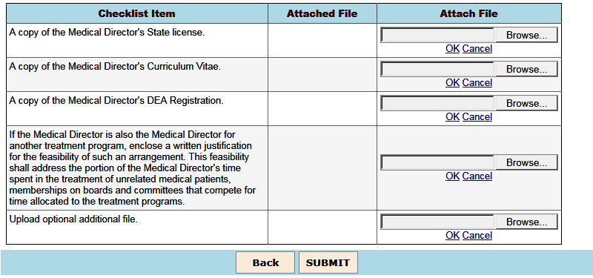

4.2.4.1 What Additional Documentation Is Needed for Each Type of SMA-162?
Required documents needed for each type of SMA-162 handled by the OTP Extranet system are listed in Exhibit 13.
Exhibit 13. Listing of Required Attachments for Each Type of SMA-162 Submitted Through the OTP Extranet System
Type of online SMA-162 | Required supplemental documents
Application for Renewal/Re-Certification | - A copy of the application to the accreditation body to which your program has applied, including the date on which the program applied for accreditation, the dates of any accreditation surveys that have taken place or are expected to take place, and the expected schedule for completing the accreditation process
Notification of Change of Program Sponsor | - No additional documents are required.
Notification of Change of Medical Director | - Copies of Medical Director’s:  - State license  - Curriculum Vitae  - DEA certificate  - If the Medical Director is also the Medical Director for another treatment program:  - Written justification for the feasibility of this arrangement including the portion of the Medical Director's time spent in activities that compete for time allocated to the OTPs.
Application for Relocation of Primary  Dispensing Unit or a Medication Unit | - A diagram and description of the facilities to be used by this program.  - Demonstrate how the facilities are adequate for drug dispensing and for individual and group counseling.  - Specify how the OTP will provide adequate medical, counseling, vocational, educational, and assessment services at the primary facility, unless the program sponsor has entered into a formal documented agreement with another entity.
Application for Addition of a New Medication Unit | - A description of how the medication unit receives the medication supply from the primary facility  - Affirmative statements that  - the medication unit is limited to administering and dispensing the narcotic treatment drug and collecting samples for drug testing or analysis, and  - the sponsor agrees to retain responsibility for patient care.

4.2.4.2 What Electronic Formats Are Accepted and When?
Electronic attachments to the online SMA-162 may be attached in any of the following file formats: .txt, .doc or .docx (i.e., MS Word), .tiff, or .pdf. For ease of completing the online application process, it is recommended that document attachments be prepared in electronic format before beginning the online SMA-162. However, it is not required that the documents be submitted at the same time as the online SMA-162. They may be attached at a later date by modifying and resubmitting the SMA-162. An online SMA-162 can be modified and resubmitted at any time up until SAMHSA completes its processing.
To expedite processing, SAMHSA recommends submitting all required attachments electronically with the online SMA-162. SAMHSA will not begin processing the form until all required additional documentation is received. Programs unable to submit the required documents as attachments to the online SMA-162 may submit them separately by ground mail, understanding that response times will be affected.

What Happens After You Submit an Online SMA-162?
After you submit an online SMA-162, a notification window appears from the OTP Extranet system (shown at the bottom of the screenshot in Exhibit 11) indicating that the form was successfully sent and that a confirmation e-mail will be sent to the e-mail address of the Program Sponsor supplied on the form. The Program Sponsor will need to click on a link in that e-mail to electronically sign the SMA-162 and complete the submission process.
SAMHSA will not begin processing an SMA-162 until the Program Sponsor has clicked on the link in the confirmation e-mail. Once the Program Sponsor has electronically signed the SMA-162
- SAMHSA will receive automated notification that an online SMA-162 has been submitted;
- An automated notification e-mail will be sent to the e-mail address of the Program Sponsor when SAMHSA begins processing the form;
- SAMHSA will contact the Program Sponsor if additional information is required;
- The purpose and status of submitted SMA-162s can be viewed from the SMA-162 menu by selecting the “Submitted SMA-162s” link under the Program Sponsor’s name, as shown in Exhibit 14; and
- An automated e-mail will be sent to the Program Sponsor when SAMHSA has completed processing the SMA-162.
Exhibit 14. Screenshot Illustrating the List of Submitted SMA-162s and Features for Viewing Their Purpose and Status
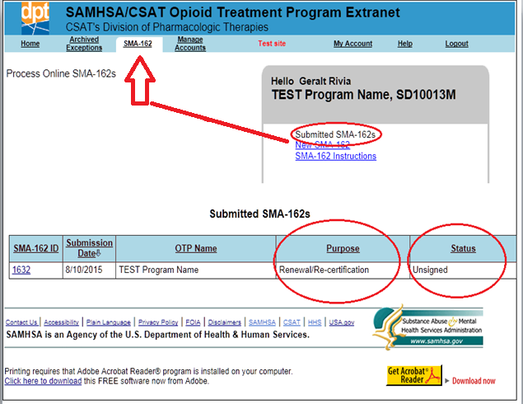
The program may modify and resubmit an online SMA-162 at any time until SAMHSA has completed processing it. Modifications could include attaching revised, new, or additional required documentation. To modify a form that has not yet been processed by SAMHSA, choose the SMA-162 form you want to modify by selecting its “SMA-162 ID” from the list of Submitted SMA-162s illustrated in Exhibit 14.

Patient Exception Request Forms (SMA-168)

SMA-168 Overview
Section 8.12 of federal regulation 42 CFR sets forth federal standards for the administration and management of opioid treatment. Included in the standards is a schedule of maximum allowable unsupervised use (i.e., take-home medications) and standards for the provision of detoxification treatment.
On occasion, patients may need exceptions from the federal opioid treatment standards due to transportation hardships, employment, vacation, medical disabilities, and so forth. In these instances, the physician must submit to SAMHSA and (where applicable) the State Opioid Treatment Authority (SOTA) an "exception request" for approval to change the patient care regimen from the requirements specified in regulation 42 CFR Part 8.
Any deviation from the opioid treatment standards set forth in regulation 42 CFR Part 8 requires the submission and approval of an SMA-168 exception request. Failure to submit an SMA-168 exception request and obtain approval from SAMHSA and (where applicable) the SOTA prior to providing care that deviates from the federal opioid treatment standards constitutes a serious regulatory violation which may threaten a program's federal and state compliance, accreditation, and certification.
As noted in Section 3.1, patient exception requests are submitted to SAMHSA and the applicable SOTA using SAMHSA form SMA-168, Exception Request and Record of Justification under 42 CFR 8.12. SAMHSA strongly recommends online submission of the form for fastest processing. SAMHSA's decision on online exception requests is typically viewable by the submitting OTP within one hour of submission.

When Should an Exception Request Be Submitted?
An SMA-168 exception request must be submitted (and approved) whenever a physician wishes to vary from the opioid treatment standards set forth in federal regulation 42 CFR Part 8.12 in the treatment of an individual patient.
The most common reasons for submitting patient exception requests are to request
- A temporary increase in the number of take-home doses permitted for unsupervised use, and
- An exception to the detoxification standards outlined in the regulation.

How Do Program Sponsors Support the OTP’s Submission of Patient Exception Requests?
Although other types of OTP Extranet account holders are more likely to play a significant role in the OTP’s online submission of patient exception requests, Program Sponsor account permissions include: creating new SMA-168s, saving an SMA-168 for later completion or for later submission by a Program Physician, and modifying an SMA-168 that has not yet been submitted by a Program Physician. OTP Extranet Users with Program Sponsor accounts can also view, print, and archive patient exception requests for their associated OTP(s). Program Sponsors do not have to complete the SMA-168 themselves; other OTP personnel also support this function by filling out SMA-168 forms and saving them for later submission by a Program Physician account holder. Most of the SMA-168 forms created in the OTP Extranet system are created by OTP users holding a Counselor account type. Nevertheless, some Program Sponsors do use their accounts to create SMA-168s themselves.

Creating an Exception Request
Exhibit 15 displays a screenshot of the OTP Extranet homepage for Program Sponsors. To create a new SMA-168, select “Create an Exception Request” from the side menu, as illustrated in Exhibit 15.
Exhibit 15. Screenshot of the OTP Extranet Homepage for Program Sponsor Accounts, Highlighting the Option to “Create an Exception Request”
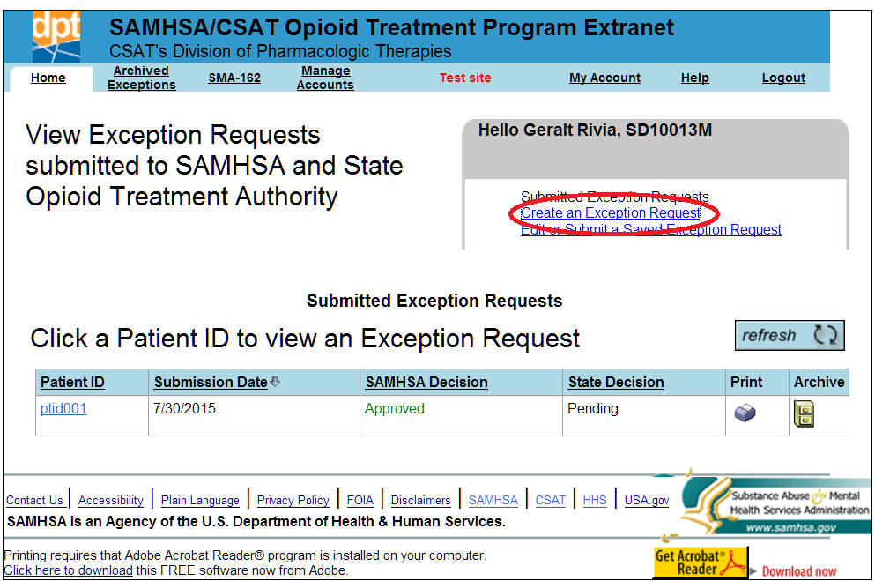
When the online SMA-168 form is opened, the requestor’s name and title are pre-populated. Exhibit 16 shows a screenshot of a new pre-populated SMA-168 form.
Exhibit 16. Screenshot of a Partial SMA-168, Newly Created with Pre-Populated Program Sponsor Name and Title
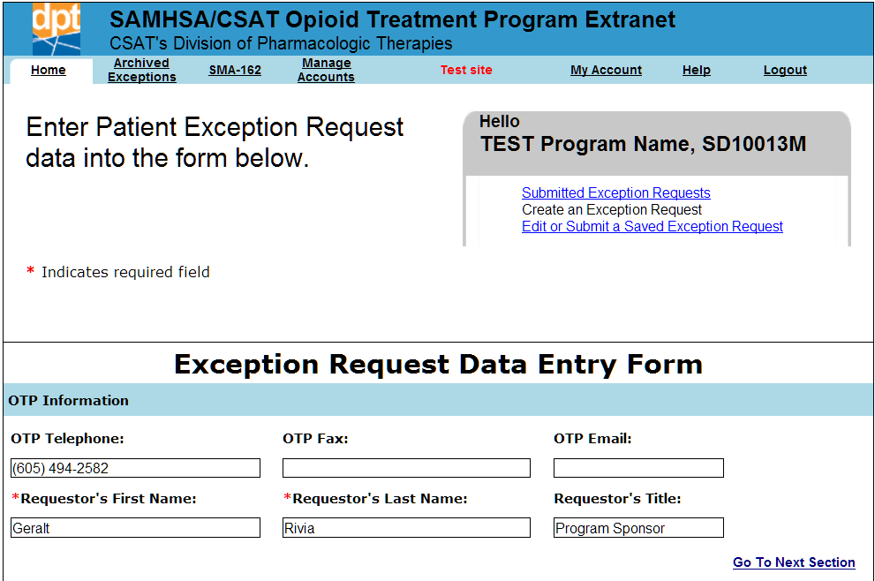
The full set of items requested on the SMA-168 are shown in Exhibit 17, along with guidance for completing the online form. The exhibit shows each item from the SMA-168 form in bold text on the left, with instructions describing the requested information on the right. Please complete ALL items on the form. As appropriate, there is space on the SMA-168 form to indicate if an item does not apply. The SMA-168 form also includes asterisks to indicate required fields. These fields are also noted by an asterisk in Exhibit 17.
Exhibit 17. Instructions for Completing the Items in SAMHSA form SMA-168
Item | Instruction
BACKGROUND INFORMATION ON PROGRAM AND PATIENT
OTP Telephone | Voice telephone number of the OTP or of the SMA-168 requester, with area code.
OTP Fax | Facsimile (FAX) number of the OTP or the SMA-168 requester, with area code.
OTP E-mail | Central electronic mail (e-mail) address for the OTP or the e-mail address of the CONTACT person for this request.
Patient ID Number* | Confidential number the program uses to identify the patient. Please do not use the patient's name or other identifying information.
Patient's Admission Date* | Date patient enrolled at this facility.
Patient's current dosage level* | Dosage patient receives NOW. Please indicate the dosage in milligrams (mg) in the provided text box.
Methadone/LAAM/Buprenorphine/Other | Select the medication the patient takes. If "Other," write in the name of the medication in the provided text box.
Patient's program attendance and schedule per week | Check each day per week the patient NOW reports to the clinic for medication.
If current attendance is less than once per week, please enter the schedule | If patient NOW reports to the clinic LESS than once a week, please indicate how often he or she reports.
Patient status | Check all items that best describe the patient's CURRENT status. If the patient's status does not appear on the list on the form, select “Other" and write in the patient's CURRENT status.
REQUIREMENTS FOR CHANGE
Nature of request* | Select from among three provided categories to BEST describe the nature of the request. If the three provided categories do not describe your request, select "Other" and describe your request in the provided text box. For security purposes, DO NOT INCLUDE PATIENT-IDENTIFYING INFORMATION IN THE TEXT BOX OTHER THAN THE PATIENT’S ID NUMBER (if needed).
Decrease regular attendance to | Select each day per week that the patient is to report for medication.
Beginning date | Enter the date that the exception is scheduled to begin.
If new attendance is less than once per week, please enter the schedule | If you are asking to reduce the patient's attendance schedule to LESS THAN once per week, please indicate the schedule on the line provided.
Dates of Exception | Please indicate the dates that the exception will be effective.
Number of doses needed | Indicate how many doses will be dispensed during the exception period.
Justification* | Please select the best description of the reason for this request from the list of provided justification categories. If the reason is not reflected in the category list, select "Other" from the category options and describe the reason for the exception request in the text box provided. Note: some of the justification categories (e.g., Transportation Hardship, Employment, Medical, and Split Dose) require a written explanation to be provided in the text box. If one of these justification categories is selected, use the text box to provide more details about the request. For security purposes, DO NOT INCLUDE PATIENT-IDENTIFYING INFORMATION IN THE TEXT BOX OTHER THAN THE PATIENT’S ID NUMBER (if needed).
REGULATION REQUIREMENTS
Three questions to confirm compliance with 42 CFR Part 8.12 | There are certain guidelines that programs must follow regarding take-home medication and detoxification admissions. Next to each of the 3 questions listed in this item on the SMA-168 form, please indicate whether the OTP followed the stipulated requirements. For each statement that does not apply, select "N/A" (not applicable).
* The asterisk denotes fields on the SMA-168 form that must be completed.

Saving an Exception Request
Program Sponsor account holders have two options after completing the SMA-168 form: saving the form for later submission or quitting without saving the form. These options are illustrated by the screenshot in Exhibit 18.
Exhibit 18. Screenshot of Options Available to Program Sponsor Account Holders After Completing an SMA-168
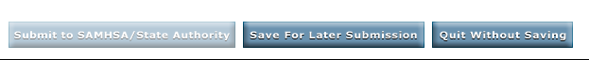
Completed forms can be saved by clicking on the “Save for Later Submission” button. If additional information is needed before finishing the form, the “Quit Without Saving” button will close the form without saving, and you will leave the page. Unless they have been approved for an OTP Extranet account that combines the permissions of a Program Physician and Program Sponsor account type, Program Sponsor account holders do not have access to the “Submit to SAMHSA/State Authority” option, as shown by the inactive “greyed out” button in Exhibit 18. This option is only active for OTP Extranet users who hold a Program Physician account type, or a Program Sponsor or Program Director account that is combined with a Program Physician account. Only the Program Physician account type has OTP Extranet system permissions to sign and submit the SMA-168.

What Happens When a Patient Exception Request Is Saved?
When the SMA-168 form is saved, the user is notified with the system’s display of the message shown in Exhibit 19.
Exhibit 19. Screenshot of a Confirmation Message Displayed by the OTP Extranet System When an SMA-168 Form Is Saved
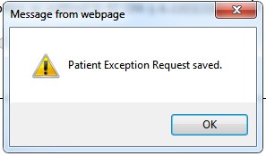
The saved form becomes accessible to the program physician for review and submission, and is automatically submitted to SAMHSA and the State Authority when it is signed by a program’s physician. All saved (but not submitted) forms appear on the Saved Exception Requests list as shown in Exhibit 20.
Exhibit 20. Screenshot Displaying the OTP’s Saved (But Not Submitted) Patient Exception Requests
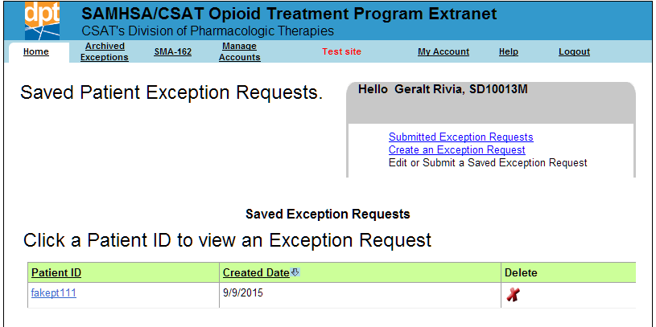
A saved SMA-168 form can be modified online by OTP personnel holding any type of OTP Extranet user account. However, no modification is allowed once the form is submitted. To modify a saved SMA-168 prior to its submission by the program physician, it should be selected from the list of “Saved Exception Requests” by clicking the link for the Patient ID associated with the request you want to modify (e.g., Patient ID “fakept111” in the screenshot shown in Exhibit 20). The selected SMA-168 may also be viewed or deleted from the “Saved Exception Requests” list.

Preferences and Account Management
Program Sponsors have system permissions to manage the user accounts of other OTP personnel for the programs associated with the Program Sponsor account. This section describes account features for managing the program’s OTP Extranet accounts and preferences for managing submitted SMA forms. Individual account management features are also discussed, including updating a password through the “My Account” tab and resetting forgotten passwords.

Managing the OTP’s Extranet Accounts
Program Sponsors have permission to disable active OTP Extranet user accounts. They can also approve or deny new OTP Extranet account requests made by OTP personnel from their programs. These features can be accessed by selecting the “Manage Accounts” tab from the top menu as shown in Exhibit 21. From this screen, the Program Sponsor is able to view an organized list of staff using the OTP Extranet system, including the assigned or requested account type for each staff member.
Exhibit 21. Screenshot of the “Manage Accounts” Menu for Viewing and Disabling Active OTP Extranet User Accounts, and Approving or Denying Account Requests
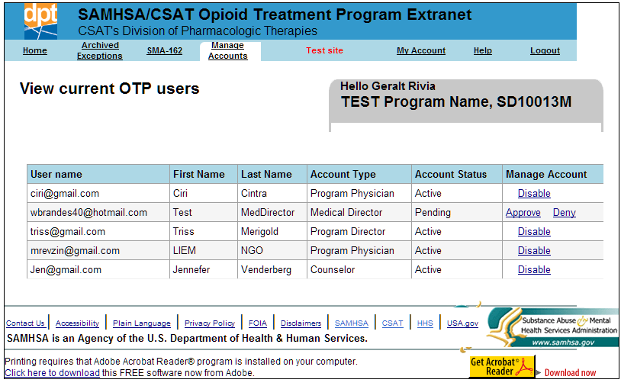
If there are pending account requests that require the action of the Program Sponsor (e.g., to approve or deny the account), the Program Sponsor is redirected to the “Manage Accounts” menu upon logging into the system.

Viewing and Monitoring Submitted SMA-162s
As described in Section 4.2.5, Program Sponsor account holders may track the purpose and status of all submitted SMA-162s by viewing the “Submitted SMA-162s” list from the main SMA-162 menu. These features were illustrated in Exhibit 14. Program Sponsors may choose to monitor the progress of their program’s SMA-162 forms through this online list.

Managing Submitted SMA-168s: Archiving and Printing
A list of the OTP’s submitted patient exception requests can be viewed by selecting the “Submitted Exception Requests” link on the Counselor user home screen as shown in Exhibit 22. By default, the list of submitted exception requests is sorted by the date the request was created, but they can be sorted by either “Created Date” or “Patient ID.”
When the list of submitted exception requests becomes long, OTP Extranet users may prefer to archive older exception requests by clicking on the “Archive” button shown in Exhibit 22.
Exhibit 22. Screenshot of Submitted Exception Requests List Highlighting Print and Archive Options
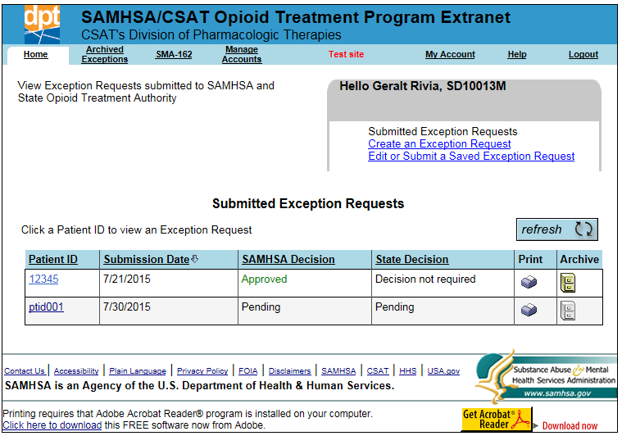
The archived SMA-168s can be viewed by selecting “Archived Exceptions” from the top menu, as shown in Exhibit 23. OTP Extranet system users wanting or needing paper copies of submitted patient exception requests can print any of the requests listed on either the “Archived Patient Exception Requests” or the “Submitted Exceptions Request” screens, as shown in Exhibits 22 and 23. Both lists also display the status of the decision as processed by SAMHSA and the State.
Exhibit 23. Screenshot of Archived Patient Exception Requests List Highlighting the Print Option
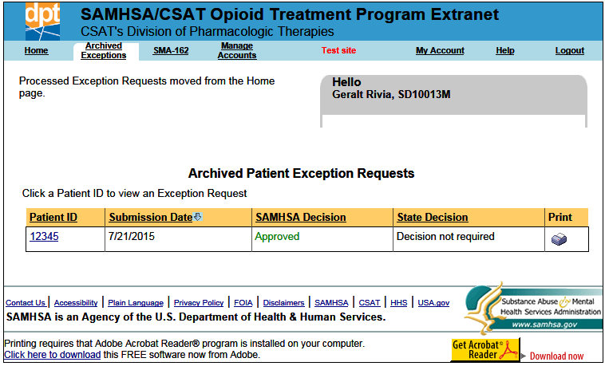

Managing Your Account

How Do I Change My Password?
As described in Section 3.3, account passwords must be changed every 90 days. To change a password from within the OTP Extranet system, select “My Account” from the top menu, as shown in Exhibit 24. The screen provides a reminder of the password requirements (described in Section 3.3 of this user guide) as well as text boxes for entering the current and new password. The new password must be entered twice to confirm its accuracy.
Exhibit 24. Screenshot of the “My Account” Tab Displaying the “Change My Password” Feature
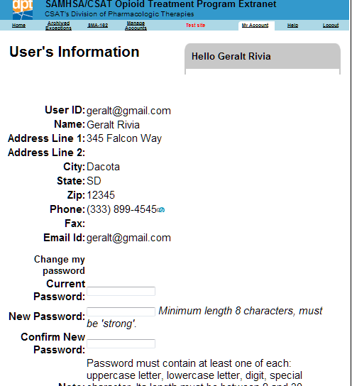

I Forgot My Password—What Do I Do?
When a password is forgotten, it must be reset. You do not need to know your password in order to reset it. The OTP Extranet website allows you to reset your password prior to logging in by using the “Forgot Password?” feature on the OTP Extranet website log-in screen. To reset a forgotten password, follow these steps:
Step 1. Go to the OTP Extranet website at https://otp-extranet.samhsa.gov.
Step 2. Click on the "Forgot password?" link at the center of the page, next to the "Sign In" button as shown in Exhibit 25.
Exhibit 25. Screenshot Displaying the OTP Extranet Log-In Site, With “Forgot Password?” Feature
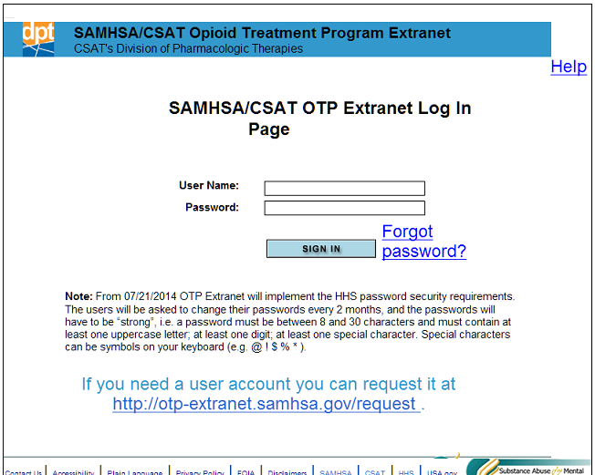
Step 3. The “Forgot password?” link leads to the log-in support screen shown in Exhibit 26.
Exhibit 26. Screenshot of Log-In Support Page, With Password Change Confirmation Pop-Up Window
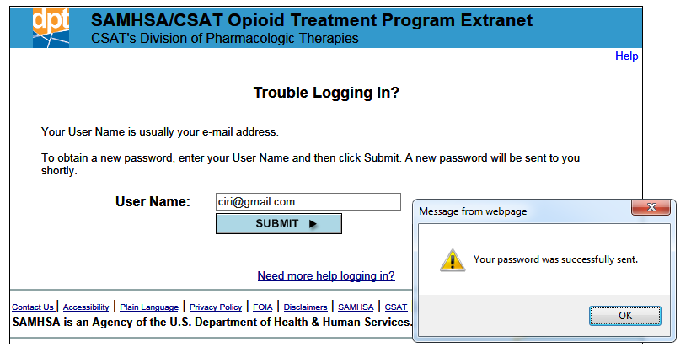
Step 4. Enter your e-mail address into the box and click “Submit.”
Step 5. A pop-up message will appear (as shown in Exhibit 26) to confirm that your password has been reset.
Step 6. You will receive an e-mail with the new temporary password. If the message is not in your inbox, you may need to check your spam or junk e-mail folders.
Step 7. Once you log in with the temporary password, you will be prompted to change it. Directions for changing a password are provided Section 5.4.1 of this user guide.
Please note: for security reasons, the SAMHSA OTP Extranet Information Center staff cannot look up your password. Therefore, the above steps must be taken to reset a forgotten password.

4171_10/15

As noted in Section 1.2, some OTP Extranet Program Sponsor account holders also hold a Program Physician user account. Users with a “combined” account should also review the Program Physician user guide for permissions not covered in the Program Sponsor user guide.
This does not create the accounts but supports SAMHSA in its validation of the authenticity of requests and appropriateness of the requestor’s OTP Extranet system access rights.
There is one exception: When an OTP does not have an existing Program Sponsor with an OTP Extranet account, SMA-162s to inform SAMHSA of a new Program Sponsor are submitted via the SAMHSA MAT website at http://www.samhsa.gov/medication-assisted-treatment/opioid-treatment-programs/program-changes#program-sponsor. For programs whose existing Program Sponsor already holds an OTP Extranet account, SMA-162s to change to a new Program Sponsor are submitted via the existing Program Sponsor’s account through the OTP Extranet Website at http://otp-extranet.samhsa.gov.

