Using the SAMHSA OTP
Extranet System:
Counselor User Accounts
Completed by the American Institutes for Research under a grant to AATOD through the Substance Abuse and Mental Health Services Administration/DHHS
Contract # HHSP233201400268P

Using the SAMHSA OTP
Extranet System:
Counselor User Accounts
October 2015
Completed by the American Institutes for Research under a grant to AATOD through the Substance Abuse and Mental Health Services Administration/DHHS
Contract # HHSP233201400268P
1000 Thomas Jefferson Street NW
Washington, DC 20007-3835
202.403.5000
www.air.org

Contents
1. Overview of the OTP Extranet System 1
1.1. OTP Extranet System Features 1
1.2. Types of User Accounts In the OTP Extranet System 1
2. Purpose of This User Guide 2
3. Establishing Counselor User Accounts 2
3.1. Overview of the Counselor User Account 2
3.2. Requesting Counselor User Accounts 3
3.3. Selecting a Password 7
4. Counselor Account Permissions and Responsibilities 8
4.1. Patient Exception Request Forms (SMA-168) 8
4.1.1. SMA-168 Overview 8
4.1.2. When Should an Exception Request Be Submitted? 9
4.1.3. How Do Counselors Support the OTP’s Submission of Patient Exception Requests? 9
4.1.4. Creating an Exception Request 9
4.1.5. Saving an Exception Request 12
4.1.6. What Happens When a Patient Exception Request Is Saved? 13
5. Preferences and Account Management 14
5.1. Managing Submitted SMA-168s: Archiving and Printing 14
5.2. Managing Your Account 14
5.2.1. How Do I Change My Password? 14
5.2.2. I Forgot My Password—What Do I Do? 15

Exhibits
Exhibit 1. Required Steps for Creating a Counselor User Account 3
Exhibit 2. Screenshot of the OTP Extranet User Account Request Form homepage, Emphasizing the Counselor Account Type Menu Option 4
Exhibit 3. Screenshot of the Counselor Account Request Form (Partial Contents) 5
Exhibit 4. OTP Extranet Counselor Account Terms of Use, Extracted from the Online Counselor Account Request Form 4
Exhibit 5. Screenshot of Automatically Generated Webpage Confirming Receipt of Counselor Account Request 4
Exhibit 6. Screenshot of the OTP Extranet Homepage for Counselor Accounts, Highlighting the Option to “Create an Exception Request” 10
Exhibit 7. Screenshot of a Partial SMA-168, Newly Created with Pre-Populated Counselor Name and Title 10
Exhibit 8. Instructions for Completing the Items in SAMHSA form SMA-168. 10
Exhibit 9. Screenshot of Options Available to Counselor Account Holders After Completing an SMA-168. 12
Exhibit 10. Screenshot of a Confirmation Message Displayed by the OTP Extranet System when an SMA-168 Form is Saved. 13
Exhibit 11. Screenshot Displaying the OTP’s Saved (but not submitted) Patient Exception Requests. 13
Exhibit 12. Screenshot of Submitted Exception Requests list Highlighting Print and Archive Options. 14
Exhibit 13. Screenshot of Archived Patient Exception Requests list Highlighting Print option. 15
Exhibit 14. Screenshot of the “My Account” tab Displaying the “Change My Password” feature. 15
Exhibit 15. Screenshot Displaying the OTP Extranet log-in site, with “Forgot Password?” feature 16
Exhibit 16. Screenshot of Log-In Support Page, with Password Change Confirmation Pop-Up Window 16

Overview of the OTP Extranet System
The OTP Extranet automated data processing website (“the OTP Extranet system”) helps the Division of Pharmacologic Therapies (DPT) —part of the Substance and Mental Health Services Administration’s (SAMHSA’s) Center for Substance Abuse Treatment (CSAT) —achieve its goal of processing the certification of SAMHSA’s opioid treatment programs (OTPs) through automated submissions and approval queues among facility, state, and federal staff. The site also supports the automated processing of provider requests for treating specific patients in a manner divergent from guidelines for opioid therapies (“patient exception requests”). The OTP Extranet system greatly increases the accuracy and ease with which CSAT is able to monitor and facilitate OTP compliance with federal regulations.

OTP Extranet System Features
Several features of the OTP Extranet system help CSAT fulfill its OTP compliance requirements in a timely manner. These features include
- Automated letter generation,
- Online submission of SAMHSA forms (“SMA forms”) approved by the Office of Management and Budget (OMB) to collect information necessary for program certifications and determinations of permissible exceptions to treating individual patients in accordance with federal opioid treatment standards, and
- Identification of impending accreditation and certification expirations.

Types of User Accounts In the OTP Extranet System
Currently there are four types of user accounts in the OTP Extranet system that are available to OTP personnel. Each is role specific, with a unique combination of user permissions:
- Counselor user account—intended for non-physician OTP staff whose job duties support the OTP’s submission of patient exception requests;
- Program Physician user account—intended for Medical Directors and other clinicians authorized to sign and submit the OTP’s patient exception requests;
- Program Director user account—intended solely for the OTP’s Program Director; and
- Program Sponsor user account—intended solely for the OTP’s Program Sponsor.
Users should note that the names of these four OTP Extranet system accounts do not always reflect the job title or position name held by the account holder at the OTP. For example, “Counselor” account holders do not have to have a job title of “counselor” at the OTP; rather, all non-physician staff who support the OTP’s submission of patient exception requests (e.g., filling out the forms for physicians to sign) may hold a “Counselor” account if approved to do so by SAMHSA and the OTP administrator. Approval of account requests is discussed in Section 3.2.
In some cases, an individual staff member meets the criteria for a Program Director or Program Sponsor account type and a Program Physician account type. For these special cases, the accounts may be combined, thus combining the permissions of the two account types.

Purpose of This User Guide
The purpose of this user guide is to provide an overview of the Counselor account type including its features and functions and to provide an accessible and user-friendly resource for users as they interact with the OTP Extranet system. Separate user guides have been developed for the Program Physician, Program Director, and Program Sponsor account types. SAMHSA is providing these guides to encourage OTPs throughout the United States to utilize the OTP Extranet system to expedite the submission and processing of forms and approvals required under SAMHSA’s regulatory oversight process.
Note: If this guide does not sufficiently address specific questions you have about Program Sponsor user accounts, please contact the SAMHSA OTP Extranet Information Center for assistance at 1-866-OTP-CSAT (8:30 a.m.–5 p.m. Eastern M–F) or by e-mail at
otp-extranet@opioid.samhsa.gov.

Establishing Counselor User Accounts
This section provides an overview of the Counselor user account, describing for whom this account type is intended as well as brief information on permissions and restrictions. The process of requesting a Counselor user account is also described, as well as approvals for account requests and password requirements that must be followed.

Overview of the Counselor User Account
Counselor user accounts are available to individuals currently employed at a SAMHSA-certified OTP. The Counselor account type is intended for all non-physician staff involved in creating, modifying, processing, or otherwise handling OMB form SMA-168, the Exception Request and Record of Justification under 42 CFR 8.12. An SMA-168 must be submitted and approved whenever a physician wishes to vary from the opioid treatment standards set forth in federal regulation 42 CFR Part 8.12 in the treatment of an individual patient. All OTP Extranet system users supporting the OTP’s submission of form SMA-168 require an individual user account; accounts should not be shared among staff.
Counselor account holders can have one user account for each OTP in which they work. A person’s e-mail address is used as the username. If a non-physician staff member supports the submission of SMA-168 forms at more than one OTP, he or she will need a separate Counselor account for each OTP. Each Counselor account must be associated with a separate e-mail address. The Counselor account type cannot be combined with any other type of OTP Extranet user account. For security purposes, any OTP Extranet user account that is not used for a year is deactivated.
Users with Counselor accounts can
- Create, save, and modify SMA-168s; and
- View and print all signed/submitted and archived SMA-168s for the OTP(s) with which their accounts are associated.
Users with Counselor accounts cannot
- Sign or submit an SMA-168 form. A user must have a Program Physician user account type in order to sign and submit an SMA-168.

Requesting Counselor User Accounts
As shown in Exhibit 1, there are seven steps in creating a Counselor user account.
Exhibit 1. Required Steps for Creating a Counselor User Account
STEPS | ACTIVITIES
Step 1 | Request an Account. Visit http://otp-extranet.samhsa.gov/request
Step 2 | Select the “Counselor” tab. This will launch the Counselor Account Request Form.
Step 3 | Complete the Counselor Account Request Form. All fields are mandatory, except for “program address line 2.”
Step 4 | Accept the Terms of Use. Review the account Terms of Use and indicate acceptance and understanding.
Step 5 | Review the Submission Confirmation Page. Receive and view a confirmation webpage indicating SAMHSA’s receipt of the Counselor Account Request Form.
Step 6 | Check e-mail. Receive and review an e-mail from otp-extranet@opioid.samhsa.gov—the SAMHSA OTP Extranet Information Center’s mailbox.
Step 7 | Respond to the e-mail Within 7 Days. No text is necessary in the response; click reply and then click send. This will complete your request for an account.
These steps are further described below; screen shots from the OTP Extranet system are provided where appropriate.
The first step in creating a Counselor account is to submit a request for an account at
http://otp-extranet.samhsa.gov/request. When the OTP Extranet User Account Request Form homepage appears, select the “Counselor” option (illustrated in Exhibit 2 below). This will bring up the Counselor Account Request Form (shown in Exhibit 3).
The Counselor Account Request Form obtains includes basic contact information about the applicant (e.g., first and last name, e-mail address) and about the OTP for which the Counselor account is being created (e.g., OTP program name, program ID number, OTP address and phone number). All fields on this form are mandatory, except for “Program Address Line 2.” As noted on the form (and included in the screenshot in Exhibit 3), the Counselor account applicant must be the only person with access to the e-mail account entered on the form. The “Program ID Number” entered on the form should be the program’s official OTP Number, sometimes known as a SAMHSA number.
After completing the information fields, review the account’s Terms of Use provided at the bottom of the form (Exhibit 4). Indicating acceptance and understanding of the Terms of Use will complete your online form submission. You will then view a confirmation webpage (Exhibit 5). This page lets the applicant know that the request was received and that a confirmation e-mail will be sent to the applicant after the form is submitted.
As indicated in the screenshot of the confirmation webpage shown in Exhibit 5, each applicant who completes a Counselor Account Request Form will receive a confirmation e-mail. Reply to the confirmation e-mail within 7 days using the same e-mail address to which the confirmation e-mail was sent. No text is needed in the body of the e-mail reply; simply hit “reply” and send the e-mail. SAMHSA OTP Extranet Information Center staff can process the account request only after receiving a reply to the confirmation e-mail. If a reply is not received within 7 days, Information Center staff consider the request to be unverified and a new Counselor Account Request Form will need to be completed and submitted.
Upon receipt of the e-mail reply, SAMHSA will verify your current employment at the program for which you are requesting the account, and will obtain permission from the program’s administrator to create the account. An e-mail notification containing a temporary password for accessing the Counselor account will be sent to you.
Exhibit 2. Screenshot of the OTP Extranet User Account Request Form Homepage, Emphasizing the Counselor Account Type Menu Option
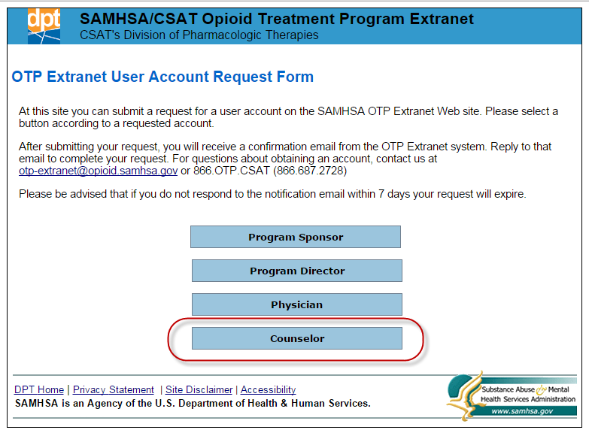
Exhibit 3. Screenshot of the Counselor Account Request Form (Partial Contents)
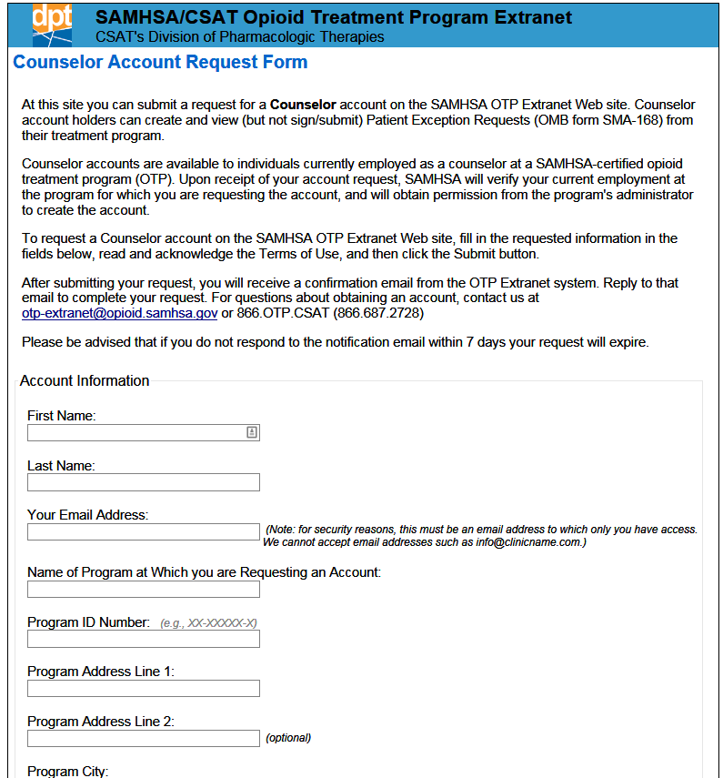
Exhibit 4. OTP Extranet Counselor Account Terms of Use, Extracted from the Online Counselor Account Request Form
OTP Extranet Counselor Account Terms of Use
- I am requesting a Counselor account on SAMHSA OTP Extranet website,
https://otp-extranet.samhsa.gov, a U.S. Government website.
- Unauthorized use of the system is prohibited and subject to criminal and civil penalties.
- My use of the system indicates consent to monitoring, recording and auditing.
- I will use the system to create, view, and print Exception Requests only under the supervision of a treating physician.
- I will not give my account username and password to another person, including my supervisor, program physician, or a computer support person (Note: SAMHSA will never request your password, in e-mail or other form).
- I will immediately alert the SAMHSA OTP Extranet Information Center and my supervisor if I become aware of any unauthorized attempts to gain access to my account, of unauthorized or inappropriate use of system.
- Upon termination for any reason of my employment at the treatment program associated with my account, I will immediately notify the SAMHSA OTP Extranet Information Center, and my account will be disabled.
- I will not enter patient name, gender, date of birth, address or other identifying information into the system.
- I have a copy of, or access to 42 CFR Part 2, Confidentiality of Alcohol and Drug Abuse Patient Records. I have read and understand the requirements to maintain the confidentiality of alcohol and drug abuse treatment patient records. I agree to protect the identity of all patients in accordance with the regulations.
❑ I have read, understand, and agree to abide by these Terms of Use and fully understand the security, privacy and confidentiality requirements of the SAMSHA OTP Extranet system and data. I further understand that violation of these terms may be grounds for administrative and/or disciplinary action by the federal and/or state government and may result in actions up to and including termination or prosecution under federal law.
Exhibit 5. Screenshot of Automatically Generated Webpage Confirming Receipt of Counselor Account Request
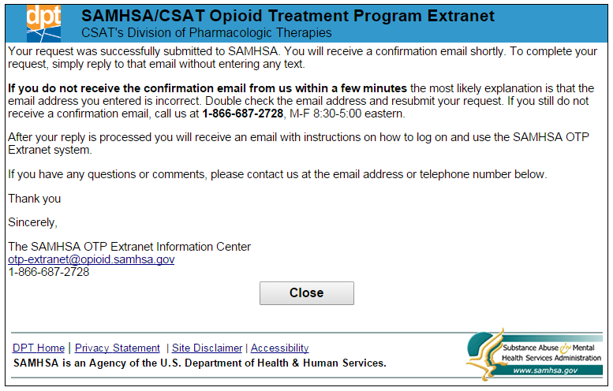

Selecting a Password
You will be prompted to change the password the first time you log in to the OTP Extranet system with your new account. Your password must meet the following Department of Health and Human Services (HHS) security requirements:
- Must be between 8 and 30 characters.
- Must contain at least one uppercase (capital) letter (e.g., A, B, etc.), and at least one lower case letter (e.g., a, b, c, etc.)
- Must contain at least one digit (e.g., 1, 2, 3, etc.).
- Must contain at least one special character. Special characters can be a punctuation mark or any other symbol on your keyboard (e.g., @ ! $ % * ? +).
- Cannot include any actual words (referred to as “dictionary words”). For example, you may not use the word “book” in your password, but you may use”b00k” instead (using zeroes instead of the letter “o”). Certain common names may also be considered words, so please keep this in mind when selecting a password.
Once your account is established, you will be required to change your password every 90 days. Instructions for changing your password, and for resetting a forgotten password are provided in section 5.2 of this user guide.

Counselor Account Permissions and Responsibilities
This section provides additional information about the SMA-168 and describes Counselor account permissions related to an OTP’s online submission of patient exception requests. These permissions include the following:
- Creating a new SMA-168;
- Saving an SMA-168 for later completion, or for later submission by a Program Physician account holder;
- Modifying an SMA-168 that has not yet been submitted by a Program Physician account holder; and
- Viewing, printing, and archiving patient exception requests for the OTP(s) associated with the Counselor’s account(s).

Patient Exception Request Forms (SMA-168)

SMA-168 Overview
Section 8.12 of federal regulation 42 CFR sets forth federal standards for the administration and management of opioid treatment. Included in the standards is a schedule of maximum allowable unsupervised use (i.e., take-home medications), and standards for the provision of detoxification treatment.
On occasion, patients may need exceptions from the federal opioid treatment standards due to transportation hardships, employment, vacation, medical disabilities, and so forth. In these instances, the physician must submit to SAMHSA and (where applicable) the State Opioid Treatment Authority (SOTA) an “exception request” for approval to change the patient care regimen from the requirements specified in regulation 42 CFR Part 8.
Any deviation from the opioid treatment standards set forth in regulation 42 CFR Part 8 requires the submission and approval of an SMA-168 exception request. Failure to submit an SMA-168 exception request and obtain approval from SAMHSA and (where applicable) the SOTA prior to providing care that deviates from the federal opioid treatment standards constitutes a serious regulatory violation which may threaten a program’s federal and state compliance, accreditation, and certification.
As noted earlier, exception requests are submitted to SAMHSA and the applicable SOTA using SAMHSA form SMA-168, Exception Request and Record of Justification under 42 CFR 8.12. SAMHSA strongly recommends on-line submission of the form for fastest processing. SAMHSA’s decision on on-line exception requests is typically viewable by the submitting OTP within one hour of submission.

When Should an Exception Request Be Submitted?
An SMA-168 exception request must be submitted (and approved) whenever a physician wishes to vary from the opioid treatment standards set forth in federal regulation 42 CFR Part 8.12 in the treatment of an individual patient.
The most common reasons for submitting patient exception requests are to request
- A temporary increase in the number of take-home doses permitted for unsupervised use, and
- An exception to the detoxification standards outlined in the regulation.

How Do Counselors Support the OTP’s Submission of Patient Exception Requests?
Counselor account permissions related to an OTP’s online submission of patient exception requests include creating new SMA-168s, saving an SMA-168 for later completion or for later submission by a Program Physician, and modifying an SMA-168 that has not yet been submitted by a Program Physician. OTP Extranet users with Counselor accounts can also view, print, and archive patient exception requests for the OTP(s) associated with their Counselor account(s).

Creating an Exception Request
Exhibit 6 displays a screenshot of the OTP Extranet home page for Counselors. To create a new SMA-168, select “Create an Exception Request” from the side menu, as illustrated in Exhibit 6.
When the online SMA-168 form is opened, the requestor’s name and title are pre-populated. Exhibit 7 shows a screenshot of a new pre-populated SMA-168 form.
The full set of items requested on the SMA-168 are shown in Exhibit 8, along with guidance for completing the online form. The exhibit shows each item from the SMA-168 form in bold text on the left, with instructions describing the requested information on the right. Please complete ALL items on the form. As appropriate, there is space on the SMA-168 form to indicate if an item does not apply. The SMA-168 form also includes asterisks to indicate required fields. These fields are also noted by an asterisk in Exhibit 8.
Exhibit 6. Screenshot of the OTP Extranet Homepage for Counselor Accounts, Highlighting the Option to “Create an Exception Request”
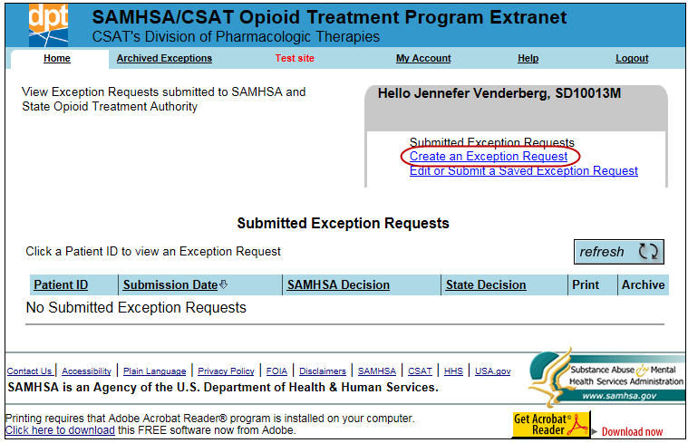
Exhibit 7. Screenshot of a Partial SMA-168, Newly Created With Pre-Populated Counselor Name and Title
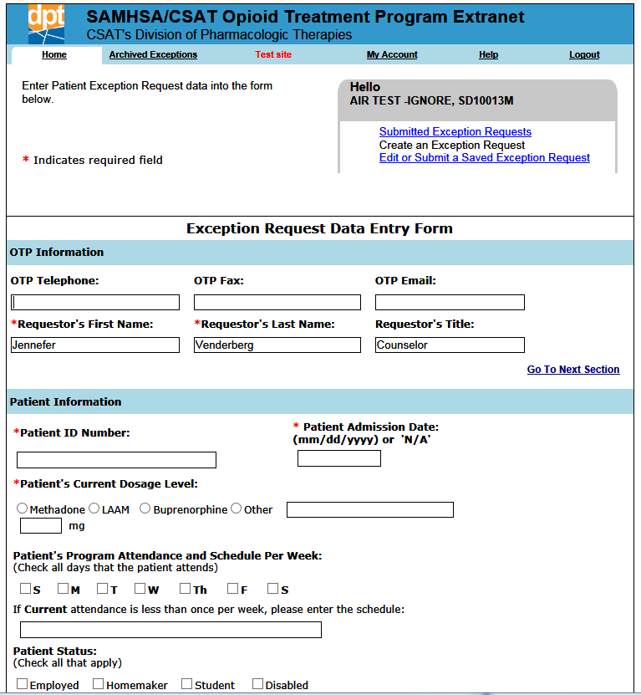
Exhibit 8. Instructions for Completing the Items in SAMHSA Form SMA-168
Item | Instruction
BACKGROUND INFORMATION ON PROGRAM AND PATIENT
OTP Telephone | Voice telephone number of the OTP or of the SMA-168 requester, with area code.
OTP Fax | Facsimile (FAX) number of the OTP or the SMA-168 requester, with area code.
OTP E-mail | Central electronic mail (e-mail) address for the OTP or the e-mail address of the CONTACT person for this request.
Patient ID Number* | Confidential number the program uses to identify the patient. Please do not use the patient's name or other identifying information.
Patient's Admission Date* | Date patient enrolled at this facility.
Patient's current dosage level* | Dosage patient receives NOW. Please indicate the dosage in milligrams (mg) in the provided text box.
Methadone/LAAM/Buprenorphine/Other | Select the medication the patient takes. If "Other," write in the name of the medication in the provided text box.
Patient's program attendance and schedule per week | Check each day per week the patient NOW reports to the clinic for medication.
If current attendance is less than once per week, please enter the schedule | If patient NOW reports to the clinic LESS than once a week, please indicate how often he or she reports.
Patient status | Check all items that best describe the patient's CURRENT status. If the patient's status does not appear on the list on the form, select “Other" and write in the patient's CURRENT status.
REQUIREMENTS FOR CHANGE
Nature of request* | Select from among three provided categories to BEST describe the nature of the request. If the three provided categories do not describe your request, select "Other" and describe your request in the provided text box. For security purposes, DO NOT INCLUDE PATIENT-IDENTIFYING INFORMATION IN THE TEXT BOX OTHER THAN THE PATIENT’S ID NUMBER (if needed).
Decrease regular attendance to | Select each day per week that the patient is to report for medication.
Beginning date | Enter the date that the exception is scheduled to begin.
If new attendance is less than once per week, please enter the schedule | If you are asking to reduce the patient's attendance schedule to LESS THAN once per week, please indicate the schedule on the line provided.
Dates of Exception | Please indicate the dates that the exception will be effective.
Number of doses needed | Indicate how many doses will be dispensed during the exception period.
Justification* | Please select the best description of the reason for this request from the list of provided justification categories. If the reason is not reflected in the category list, select "Other" from the category options and describe the reason for the exception request in the text box provided. Note: some of the justification categories (e.g., Transportation Hardship, Employment, Medical, and Split Dose) require a written explanation to be provided in the text box. If one of these justification categories is selected, use the text box to provide more details about the request. For security purposes, DO NOT INCLUDE PATIENT-IDENTIFYING INFORMATION IN THE TEXT BOX OTHER THAN THE PATIENT’S ID NUMBER (if needed).
REGULATION REQUIREMENTS
Three questions to confirm compliance with 42 CFR Part 8.12 | There are certain guidelines that programs must follow regarding take-home medication and detoxification admissions. Next to each of the 3 questions listed in this item on the SMA-168 form, please indicate whether the OTP followed the stipulated requirements. For each statement that does not apply, select "N/A" (not applicable).
*The asterisk denotes fields on the SMA-168 form that must be completed.

Saving an Exception Request
Counselor account holders have two options after completing the SMA-168 form: saving the form for later submission or quitting without saving the form. These options are illustrated by the screenshot in Exhibit 9.
Exhibit 9. Screenshot of Options Available to Counselor Account Holders After Completing an
SMA-168
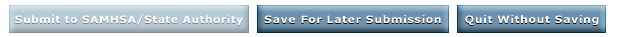
Completed forms can be saved by clicking on the “Save for Later Submission” button. If additional information is needed before finishing the form, the “Quit Without Saving” button will close the form without saving, and you will leave the page. Counselor account holders do not have access to the “Submit to SAMHSA/State Authority” option, as shown in Exhibit 9. This option is only active for OTP Extranet users who hold a Program Physician account type. Only the Program Physician account type has OTP Extranet system permissions to sign and submit the SMA-168.

What Happens When a Patient Exception Request Is Saved?
When the SMA-168 form is saved, the user is notified with the system’s display of the message shown in Exhibit 10.
Exhibit 10. Screenshot of a Confirmation Message Displayed By the OTP Extranet System When an SMA-168 Form Is Saved.
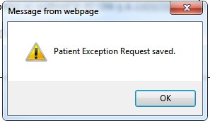
The saved form becomes accessible to the program physician for review and submission, and is automatically submitted to SAMHSA and the State Authority when it is signed by a program’s physician. All saved (but not submitted) forms appear on the Saved Exception Requests list as shown in Exhibit 11.
Exhibit 11. Screenshot Displaying the OTP’s Saved (But Not Submitted) Patient Exception Requests
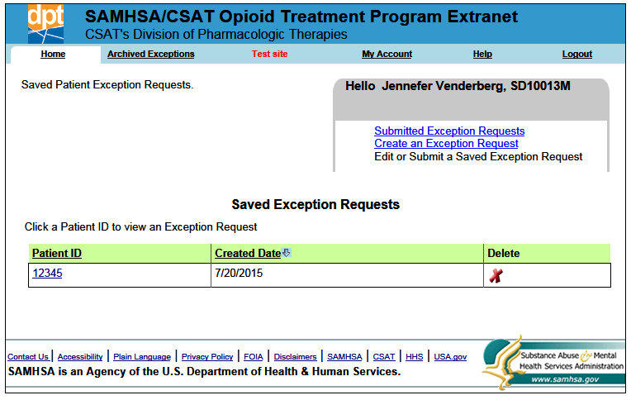
A saved SMA-168 form can be modified online by OTP personnel holding any type of OTP Extranet user account. However no modification is allowed once the form is submitted. To modify a saved SMA-168 prior to its submission by the program physician, it should be selected from the list of “Saved Exception Requests” by clicking the link for the Patient ID associated with the request you want to modify (e.g., Patient ID “12345” in the screenshot shown in Exhibit 11).

Preferences and Account Management
This section describes account features for managing submitted SMA-168s. Account management features are also discussed, including updating a password through the “My Account” tab and resetting forgetting passwords.

Managing Submitted SMA-168s: Archiving and Printing
A list of the OTP’s submitted patient exception requests can be viewed by selecting the “Submitted Exception Requests” link on the Counselor user home screen as shown in Exhibit 12. When the list of submitted exception requests becomes long, OTP Extranet users may prefer to archive older exception requests by clicking the “Archive” button shown in the exhibit.
Exhibit 12. Screenshot of Submitted Exception Requests List Highlighting Print and Archive Options
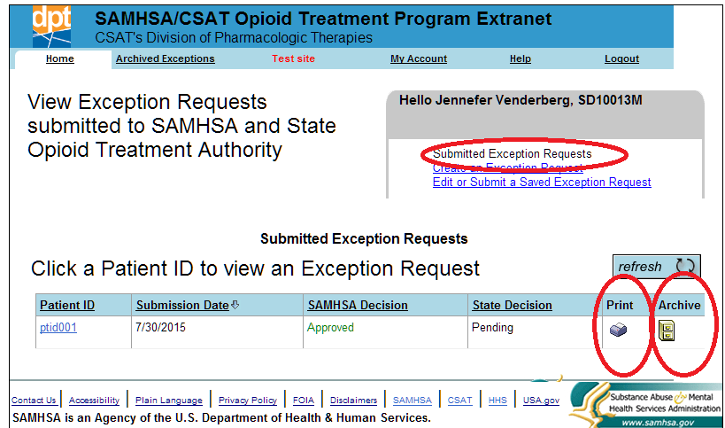
The archived SMA-168s can be viewed by selecting “Archived Exceptions” from the top menu, as shown in Exhibit 13. OTP Extranet system users wanting or needing paper copies of submitted patient exception requests can print any of the requests listed on either the “Archived Patient Exception Requests” or the “Submitted Exceptions Request” screens, as shown in Exhibits 12 and 13. Both lists also display the status of the decision as processed by SAMHSA and the State.

Managing Your Account

How Do I Change My Password?
As described in Section 3.3., account passwords must be changed every 90 days. To change a passwords from within the OTP Extranet system, select “My Account” from the top menu, as shown in Exhibit 14. The screen provides a reminder of the password requirements (described in Section 3.3. of this user guide), as well as text boxes for entering the current and new password. The new password must be entered twice to confirm its accuracy.
Exhibit 13. Screenshot of Archived Patient Exception Requests List Highlighting Print Option
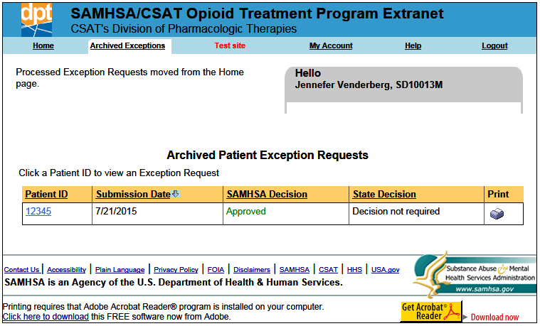
Exhibit 14. Screenshot of the “My Account” Tab Displaying the “Change My Password” Feature
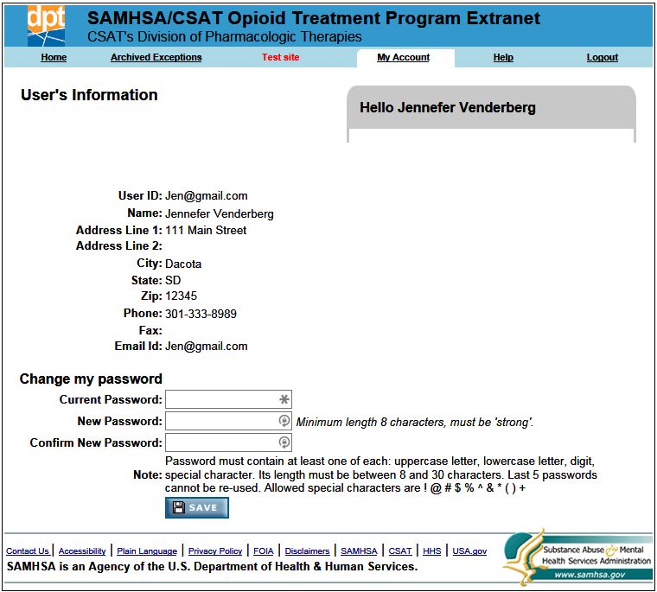

I Forgot My Password—What Do I Do?
When a password is forgotten, it must be reset. You do not need to know your password in order to reset it. The OTP Extranet website allows you to reset your password prior to logging in by using the “Forgot Password?” feature on the OTP Extranet website log in screen. To reset a forgotten password, follow these steps:
Step 1. Go to the OTP Extranet website at https://otp-extranet.samhsa.gov.
Step 2. Click on the “Forgot password?” link at the center of the page, next to the “Sign In” button as shown in Exhibit 15.
Exhibit 15. Screenshot Displaying the OTP Extranet Log-In Site, With “Forgot Password?” Feature
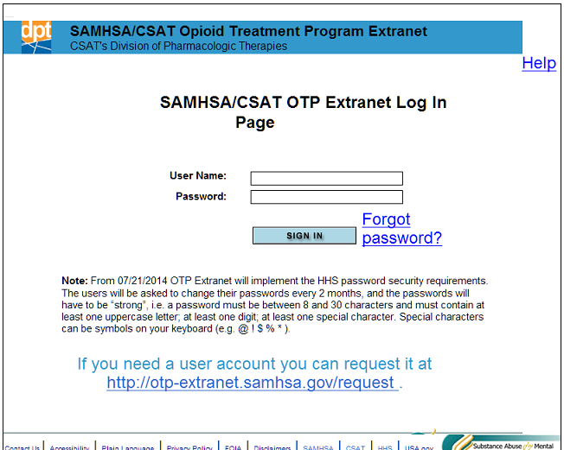
Step 3. The “Forgot password?” link leads to the log-in support screen shown in Exhibit 16.
Exhibit 16. Screenshot of Log-In Support Page, With Password Change Confirmation Pop-Up Window
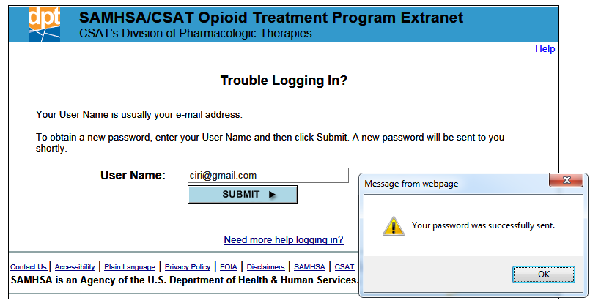
Step 4. Enter your e-mail address into the box and click “Submit.”
Step 5. A pop-up message will appear (as shown in Exhibit 15) to confirm that your password has been reset.
Step 6. You will receive an e-mail with the new temporary password. If the message is not in your inbox, you may need to check your spam or junk e-mail folders.
Step 7. Once you log in with the temporary password, you will be prompted to change it. Directions for changing a password are provided Section 5.2.1 of this user guide.
Please note: for security reasons, the SAMHSA OTP Extranet Information Center staff cannot look up your password. Therefore, the above steps must be taken to reset a forgotten password.

4171_10/15

